Lambda function AWS2ZabbixASGRemove Installation Guide

Client logo

Tooling & Automation

Partner logo

Contents

1. Introduction 3

2. Solution description 4

3. General information 4

4. Used Services 4

5. Data sent 5

6. Deploy process 5

6.1. Setup communication to AWS account 6

6.2. Adjusts Terraform variables values 6

6.3. Apply the configuration 7

6.4. Validate the communication 7

# Introduction

This document explains how to install lambda function AWS2ZabbixASGRemove.

# Solution description

Deploy all components to inform Zabbix that the EC2 instance is permanently stopped.

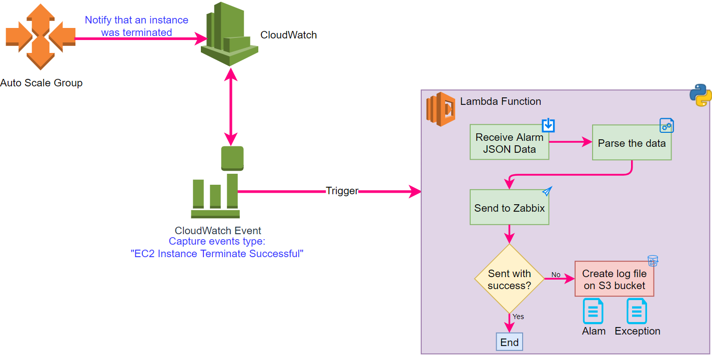

The terraform code is available in aws2zabbixasgremove.zip archive.

# General information

This function will notify the Zabbix when the ASG terminate an EC2 to Zabbix remove the instance of monitoring.

How all communication must be done safely, the Lambda function is deployed in some VPC to be able to communicate through a VPN, VPN peering or other safe way.

# Used Services

* Lambda function
* IAM Role and Policy
* Simple Storage Service (S3)
* CloudWatch Alarm
* CloudWatch Event
* Custom security groups

# Data sent

This function will send the data to Zabbix with the structure below: 

# Deploy process

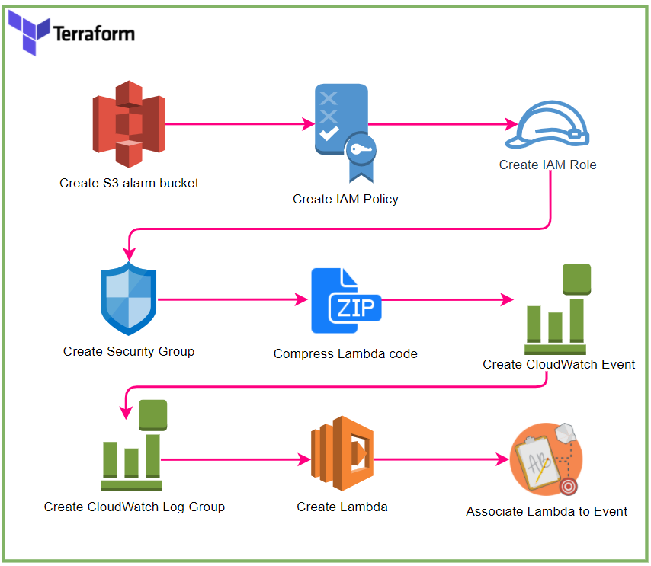

## Setup communication to AWS account

Configure the credentials to communicate to AWS.

This step depending of the customer CI/CD solution, on Azure DevOps this step can be done adding a Service Connection in the project.

## Adjusts Terraform variables values

All variables must be changed on Terraform variable file (terraform.tfvars).

They were divided into groups:

**General** (General data that may be used for others scripts)

|  |  |  |  |
| --- | --- | --- | --- |
| Variable | Type | Description | Default |
| region | string | AWS region | eu-west-3 |
| env | string | Environment of the solution | prd |
| app | string | Application name | Inetum Monitoring |

**lambdaASGTerminated** (These variables are specific for AWS Lambda function)

| Variable | Type | Description | Default |
| --- | --- | --- | --- |
| name | string | Name of Lambda function | Inetum_SendASGTerminatedEC2ToZabbix |
| description | string | Description of Lambda function | Function to notify Zabbix about instance terminated by ASG |
| s3BucketName | string | S3 bucket name to save the error logs | terminatedec2 |
| s3FilePath | string | Path to save the error log files in S3 bucket | ByASG |
| vpcId | string | VPC ID to deploy the Lambda function | NULL |
| subnetIds | array | Subnets ID to deploy the Lambda function | NULL |
| logRetention | number | Retention of CloudWatch Lambda execution (days) | 30 |
| timeout | number | Timeout to execute Lambda function | 10 |

**zabbix (Information about Zabbix connection to be used in Python script on Lambda function)**

| **Variable** | **Type** | **Description** | **Default** |
| --- | --- | --- | --- |
| host | string | The IP Address or FQDN of the Zabbix Proxy (Proxy must be reacheable from the account automation) | NULL |
| port | Integer | TCP port used by Zabbix proxy to listen incoming alerts | 10052 |
| trapItem | string | Name of item on Zabbix configured to receive these alerts | autoscaling_host_deletion |
| timeout | number | timeout to connect to Zabbix server | 5 |

By default, the TF code will apply some TAGs, if necessary you can change the alarm_tags object in variables.tf file

Will be used the instanceID as clientName

## Apply the configuration

This step depending the customer CI/CD solution.

In Azure DevOps you might need to run a Pipeline and/or a Release.

In terraform CLI you might need to run the command *terraform apply*.

## Validate the communication

Get a instance that exist on Zabbix and force a terminate task, after that ask to Inetum Tooling team to check in Zabbix again if the server was removed

### Révisions

|  |  |  |
| --- | --- | --- |
| Version | Date | Objet |
| 1.0 | 27/09/2021 | Création of document |
|  |  |  |
|  |  |  |

### Visas

|  |  |  |  |
| --- | --- | --- | --- |
|  | Responsable | Date | Visas |
| Rédaction | Sophie Dupont | 27/09/2021 | SDU |
| Vérification |  |  |  |
| Approbation |  |  |  |

### Diffusion

|  |  |
| --- | --- |
| Entreprise | Destinataire |
| INETUM | Skill Center IS |
|  |  |
|  |  |